18X（1/3〞）AHD CAMERA SPECIFICATION

MODEL
FTZ18SH72-AHD

PRODUCTION

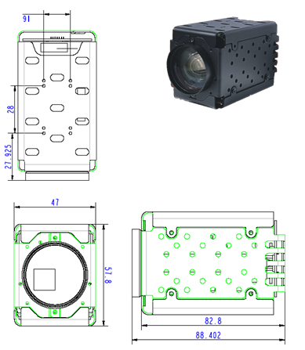

SPECIFICATION
ZOOM CAMERA
MODEL | FTZ18SH72-AHD
Resolution | 1.3Million 1280（H）X 720（V）
Communication mode | RS232
Protocol | SONY VISCA
Interface | 9P FPC
Sensor | 1/3" CMOS
Scanning mode | Progressive scanning
Day&night | Color/B&W/Auto
Mini illumination | Color：0.1Lux B&W：0.01Lux
Sync system | Inter-sync
Video out | AHD(1Vp-p 75Ω)
SNR | ≥50dB（AGC OFF）
Lens
IRCUT | IRCUT
AUTO IRIS | Support
FNO./Focal Length | 18X， f=4.7mm～84.6mm F1.6(W)～2.7(T)
FOV | H：54.8°（W）～3.4°（T） V：41°（W）～2.5°（T）
Function
Exposure Mode | Auto/Manual
AWB | Auto/Indoor/Outdoor/Manual
Focus mode | Auto/Manual
AGC | Auto/Manual
Picture effects | Auto/Color/B&W
E-ZOOM | ——
Backlight compensator | ON/OFF
Freeze | ——
Mirror | Support(LR+UD)
Rollover | Support
Blank screen | ——
WDR | D-WDR
DNR | 2D-DNR
Shutter | 1/30s~1/10,000s
DSS | ——
Contrast | Adjust
Saturation | Adjust
Defog | Support
Move detect | ——
Privacy masking | ——
Corner illumination | Support
General Specifications
Size | 50（W）* 60（H）* 90（L） mm
Working Temp./Hygro. | ﹣10℃～50℃，10％RH～60％RH
Storage Temp./Hygro. | ﹣20℃～60℃，10％RH～80％RH
Power Voltage | DC 12V±10%
Power consumption | 5W MAX
Net Weight | 270g

Pin assignment

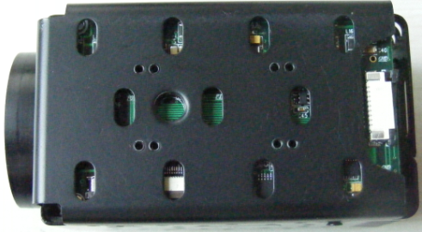
①
②③
④⑤⑥⑦⑧⑨

The Connect Pins Functions Table: the order of 1 to 9 pin location and the following table:

1 | 2 | 3 | 4 | 5 | 6 | 7 | 8 | 9
RXD | TXD | GND | DC12V | GND | AHD-OUT | GND | NC | GND

通信协议： VISCA， 波特率9600

